AmCham: LinkedIn Group Development Strategy

- Current situation:
  - 455 members
  - 2 Subgroups: IT Committee and Marketing Committee
  - Statistics:
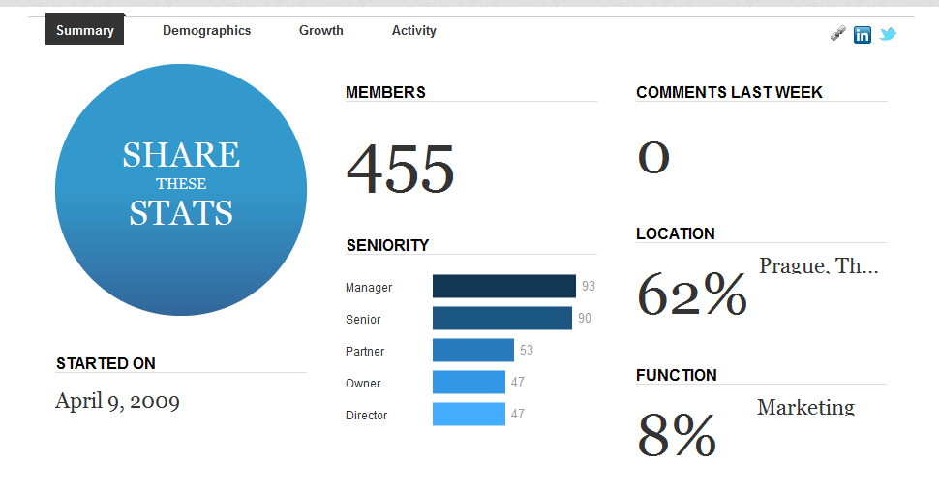
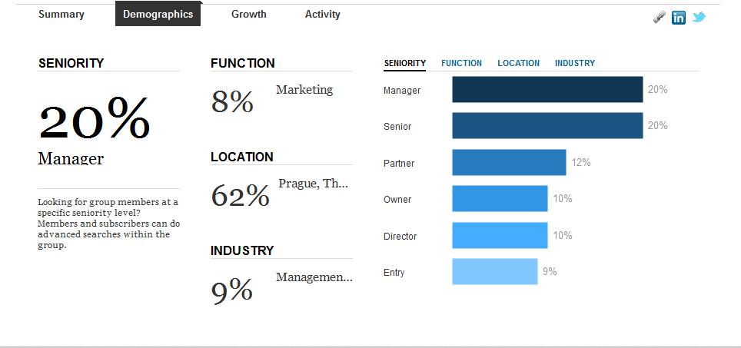
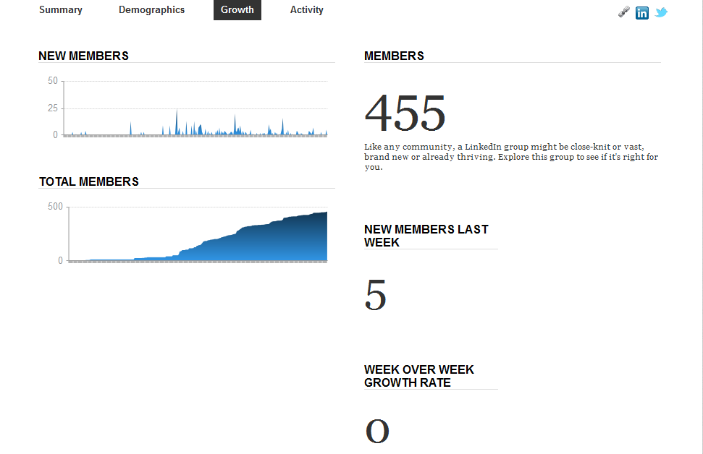
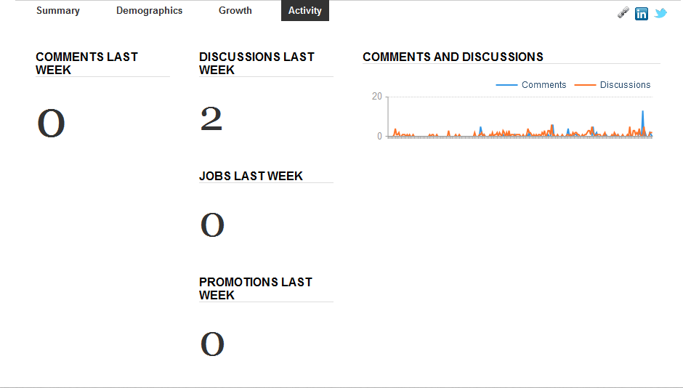

- Vision:
  - What are we trying to achieve? How do we want the group to function and look like at the end of 2016?
AmCham: Info sharing on market, management, business opportunities, central hub of business. Online discussion portal for topics being discussed at AmCham. …………………………………………………………………………………………………………………………………………………………………………………………………………………………………………………………………………………………………………………………………………………………………………………………………………………………………………………………………………………………………………………………………………………………………………………………………………………………………………………………………………………………………………………………………………………………………………………………………………………………………………………………………………………………………………………………………………………………………………………………………………………………………………………………………………………………………………………
  - How can we stimulate and engage our members:
    - To join the group?
    - To be active on the group under the form of:
      - Know-how sharing?
      - Joining the discussion?
  - …………………………………………………………………………………………………………………………………………………………………………………………………………………………………………………………………………………………………………………………………………………………………………………………………………………………………………………………………………………………………………………………………………………………………………………………………………………………………………………………………………………………………………………………………………………………………………………………………………………………………………………………………………………………………………………………………………………………………………………………………………………………………………………………………………………………………………………

- Group promotion:
  - How can we promote the group among our members?
    - CzechMarketPlace.cz
    - AmCham.cz
    - CzechCompete.cz
    - Newsletters, CMP Newspaper
    - Print publications: leaflets / periodicals / Best Office
    - Member engagement: posting info about the group on their own statuses?
  - …………………………………………………………………………………………………………………………………………………………………………………………………………………………………………………………………………………………………………………………………………………………………………………………………………………………………………………………………………………………………………………………………………………………………………………………………………………………………………………………………………………………………………………………………………………………………………………………………………………………………………………………………………………………………………………………………………………………………………………………………………………………………………………………………………………………………………………

- Steps to be taken / Tasks:
  - Review the Group profile?
  - Create + post Group functioning rules?
  - Distinguishing between company page & company group
  - …………………………………………………………………………………………………………………………………………………………………………………………………………………………………………………………………………………………………………………………………………………………………………………………………………………………………………………………………………………………………………………………………………………………………………………………………………………………………………………………………………………………………………………………………………………………………………………………………………………………………………………………………………………………………………………………………………………………………………………………………………………………………………………………………………………………………………………

